2017 Conference Program

April 23 – 26, 2017

Murfreesboro, Tennessee

2016-2017 Executive Board
President Karen Hauser, Vanderbilt University
President-Elect Charles Harper, Belmont University
Past President / Dick Smelser, Pellissippi State Community College Nominations /
TSAC Advisory
Secretary Joe Myers, Motlow Community College
Treasurer Leah Louallen, TSAC

2016-2017 Sector Representatives
Representative at Large April Cross, Lee University Private Sector Rep Danette Seale, Carson Newman Proprietary Sector Rep Mary Kidd, Nossi College of Art
Public 2-Year Rep Kacee Hardy, Dyersburg State Community College Public 4-Year Rep Stephen White, Middle Tennessee State University TCAT Rep Jo Wallace, TCAT McKenzie

2016-2017 Committee Chairs
Association Governance Jeff Gerkin, University of Tennessee Knoxville Awards Stacey Duncan, Rhodes College
Budget/Finance Terri Parchment, TSAC
Conference Charles Harper, Belmont University
Diversity Portia Cook, Cleveland State Community College Electronic Services Jeff Norrod, Tennessee Technological University Governmental Relations Ron Gambill, Edsouth
Historical Cynthia Piana, Aquinas College
Membership Melissa Smith, Vanderbilt University
Mentoring Joanna Hayes Dickens, John A. Gupton College Public Relations / Blog Celena Tulloss, University of Tennessee Knoxville FA Awareness Cherry Johnson, Columbia State Community College Site Selection Sonja McMullen, Sallie Mae
Sponsorship Lester McKenzie, Tennessee Technological University State Programs Darolyn Porter, TSAC
Training Tiffany Summers, Lipscomb University

2017 TASFAA Conference Committee

Charles Harper, Chair, Belmont University
Karen Hauser, Vanderbilt University
Leah Louallen, TSAC
April Cross, Lee University
Tiffany Summers, Lipscomb University
Portia Cook, Cleveland State Community College
Jeff Norrod, Tennessee Technological University
Melissa Smith, Vanderbilt University
Joanna Hayes-Dickens, John A Gupton College
Celena Tulloss, University of Tennessee Knoxville
Kacee Hardy, Dyersburg State Community College
Jo Wallace, TCAT McKenzie
Stephen White, Middle Tennessee State University
Lester McKenzie, Tennessee Technological University
Maggie Kersten, Lipscomb University
LeChelle Davenport, Southwest Tennessee Community College
Blake Hopson, East Tennessee State University
Kevin Jacobs, Tennessee State University
Danette Seale, Carson Newman University
Conference Logo by Jacob Lambert
Student at Memphis College of Art

ARTIST STATEMENT: Throughout my entire life, I have wanted to tell my own fictional stories. Movies,
specifically animation films, and comics have inspired me to strive and create different ideas. To tell my stories, I wanted to use animation because of the different possibilities with the technology available. While I prefer 20 animation, I am also fond of 30 animation, and I would like to be able to master both. I have always been amazed by the different and unique styles of animation used in animated movies and television shows. I want to create stories not only for others to enjoy, but for myself as well. Over the years, I have so many ideas in my head that I would like to share. Not only do I create digital artwork and animation for fun, but also for me, it is a great way to take away stress. I now attend Memphis College of Art, where I am currently majoring in animation. When I finish school, I would like to do internships and have more experiences,
so that one day I could work for either Disney or DreamWorks. I would also love to do freelance work as well and possibly start a business. It takes time and patience to do animation, but it is worth it in the end when it is finished.

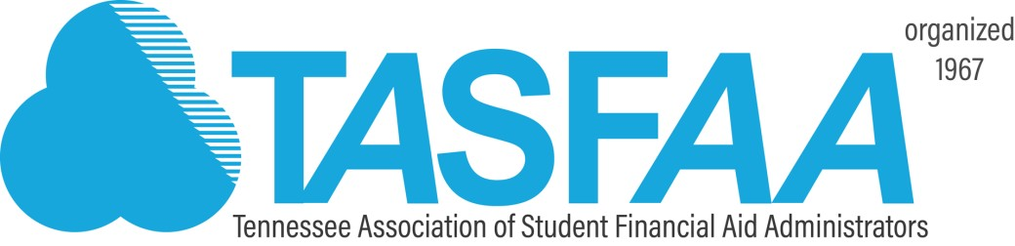

Dear TASFAA Friends,

Welcome to the 2017 annual TASFAA conference. Our conference theme, Education is Key, resonates with each of us personally and in the profession we have chosen. Members of our association serve students by providing a vital key to unlock their potential. Our common goals are to assist our students with the means to obtain an education; seek and earn academic credentials that document their educational achievements; and enjoy a higher quality of life than would be possible without higher education. We provide ways for each student to have a life that has been enriched and deepened by the learning that takes place at the institutions across our state.

Your conference committee has worked diligently to bring together a jam-packed four days. Under the leadership of Charles Harper the committee has put together an agenda that includes an ambitious collection of general and concurrent sessions which will provide numerous and meaningful learning opportunities for you. Our keynote speaker, Jonathan Bowman, will share how education was key in redirecting his life. FBI Special Agent Scott Augenbaum will deliver key information on protecting our campus’s and our personal cyber space. Of course our favorite Feds, David Bartnicki and Wood Mason, will join us to deliver current and relevant regulation updates. Designated time will be set aside so you can meet new friends, share ideas, swap stories and expand your professional network.

I want to give a huge thanks to our sponsor friends. Please visit the exhibit area often during the conference to learn about key products and services they can provide to your institutions and your students. TASFAA remains fiscally strong, in part, as a result of their financial contributions to our conference and the relationships they build with each of you.

In closing, I want to thank you from the bottom of my heart for allowing me to serve as your President during 2016-17. TASFAA has been a key to my professional and personal growth, and I am truly humbled to have been afforded the honor of serving our association.

“Education is the most powerful weapon which you can use to change the world.”
Nelson Mandela

Sincerely,
Karen Hauser
Karen Hauser TASFAA President

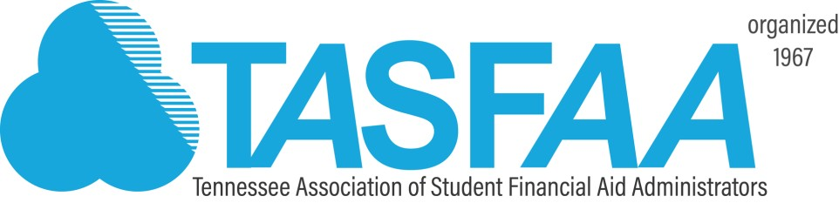

Dear TASFAA Family,

On behalf of the 2017 Conference Committee, I am excited to welcome you to our Annual TASFAA Conference!

This year’s theme, “Education is Key”, provides an opportunity for us as financial aid professionals to continue to engage, learn, and put into practice the ever changing processes while we strive to manage federal, state, and institutional regulations. We put such an emphasis on educating our students on loan debt/smart borrowing, personal finances, and even serving as mentors that we often forget that our continuing education is just as important as we work to help provide assistance to the next generation of leaders and possibly financial aid professionals. As financial aid administrators, the TASFAA conference allows us to collaborate with our colleagues and friends, to de-stress, laugh, and to find answers to the always changing questions. I personally want to give a heartfelt thank you for taking time away from your office to spend it with us at the conference and hopefully return to your institution more knowledgeable as leaders and educators in our profession.

I am pleased to open our conference with a focus on “People Power” by our Keynote Speaker, Jonathan Bowman. Jonathan is the CEO of Clear Picture Leadership. We will also be joined by several special guests throughout the conference including David Bartnicki, Wood Mason, U.S. Department of Education; Marian Dill, SASFAA President; Heather Boutell, NASFAA; Kevin Perry, South Carolina State President; John Konerman, Office of Inspector General; Scott Augenbaum, Federal Bureau of Investigation and other distinguished guests. I hope you will join me in welcoming them to Tennessee and TASFAA.

Please take time to review our program and note the Sponsor Exhibit Hall hours. Stop by often during the conference to thank our sponsors for their support of our training efforts. Their financial support is critical to the mission of TASFAA and our conference.

On Monday afternoon, plan to stay after a day of sessions to honor Karen Hauser at the President’s Reception. The TASFAA Suite will be open Monday and Tuesday evening, and we encourage everyone to stop by for networking and fellowship with old friends and new ones! Don’t forget BINGO is back on Sunday night immediately following our networking dinner.

On behalf of the Conference Committee, we hope you experience excellent training opportunities, networking, and financial aid fun!

Thank you,

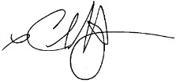
Charles Harper Conference Chair

Welcome to the 2017 TASFAA Annual Conference
Information for Conference Participants

Cell Phones/Electronic Devices
As a courtesy to presenters and attendees, please silence your cell phones and/or electronic devices during the General and Concurrent Sessions.

Conference Attire
Business casual attire is appropriate for the entire conference

Hospitality Suite
The TASFAA Hospitality Suite is on the 2nd floor in Suite 228 and welcomes all members. Hours are posted in the program. Join new friends for a pit-stop during the conference.

Meals
If you are a commuter and if you indicated on your registration that you would be eating breakfast then you should have breakfast meal tickets in your registration packet. If you did not indicate that you would be eating breakfast but you now need a meal ticket then you may stop by the registration area.

For conference lunches, individuals who requested vegetarian meals on your registration will have a vegetarian meal ticket in your registration packet. Please present the ticket to the wait staff at the luncheon and they will accommodate your request.

For members staying at the hotel, the Embassy offers a free cocktail hour from 5:30 to 7:30 pm each evening. They offer free drinks and light snacks at this event.

Name Badges
Please wear your name badge at all times as it is necessary for admission to all conference sessions and meals. If you misplace your badge, please go to the registration desk.

Embassy Suites
A floor plan/layout of the hotel is located on the last page of this program.

TASFAA 2017 Conference Sponsorship

Special Thanks
As always, the members of TASFAA express their gratitude for the continued support from generous sponsors. The Grand Patrons, Patrons, Sponsors, and Vendors have allowed us to offer this annual conference for a reasonable fee. Thank you to each and every one of our 2017 conference sponsors. Please visit each of them in the Sponsor Exhibit Hall.

Grand Patron Level

minimum $5,500

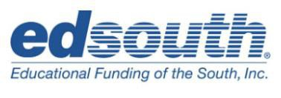

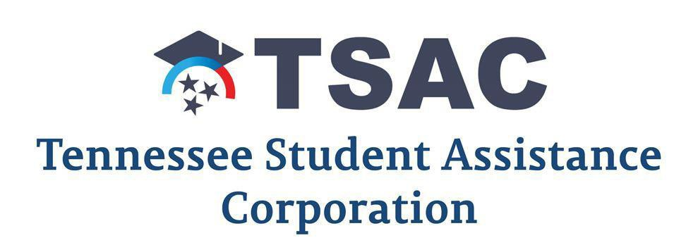

Sponsor Level
$3,000 - $3999

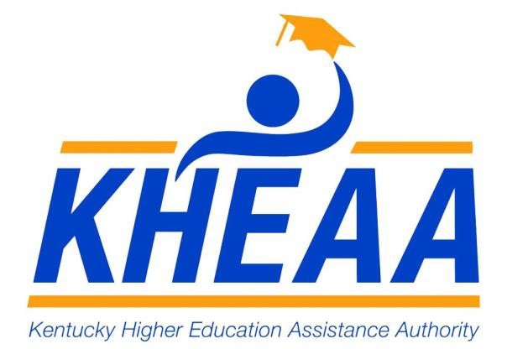

Vendor Level
$2,000-$2,999

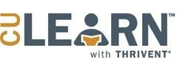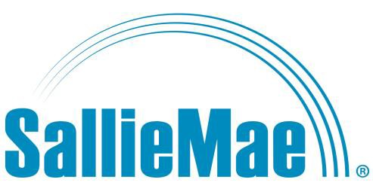

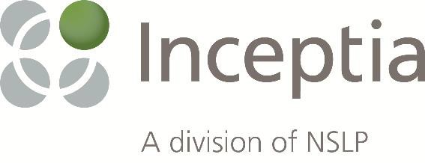

Pre-Conference Activities on Saturday, April 22, 2017

3:00 – 6:00 pm | TASFAA Hospitality Suite Open | Suite 228
6:00 pm | Dinner: Executive Board and Conference Committee | Macaroni Grill

Conference Activities on Sunday, April 23, 2017

7:00 – 8:15 am | New Aid Officers Breakfast Executive Board Breakfast | Hotel Lounge
7:45 – 9:00 am | Registration: New Aid Officers Workshop | Registration Area
8:30 – 10:15 am | New Aid Officers Workshop – Session 1 | Broadlands A
9:00 – 10:15am | Executive Board Meeting | Cambridge B
11:00 am – 2:00 pm | Sponsor Set-Up in Exhibit Hall | Oakleigh A
10:15 - 10:30 am | Break: New Aid Officers Workshop Executive Board Meeting
10:30 am – 12:00 pm | New Aid Officers Workshop – Session 2  Executive Board Meeting | Broadlands A Cambridge B
12:00 – 1:00 pm | Luncheon: New Aid Officers, Executive Board, and Conference Committee | Broadlands B
1:00 – 2:00 pm | Executive Board Meeting Continues | Cambridge B
1:00 – 2:30 pm | New Aid Officers Workshop – Session 3 | Broadlands A
2:00 – 4:45 pm | TASFAA Hospitality Suite Open Vendor Area Open  Conference Registration Open | Suite228 Oakleigh A
2:30 – 2:45 pm | Break: New Aid Officers Workshop
3:00 – 4:30 pm | New Aid Officers Workshop – Session 4 | Broadlands A
3:00 – 4:30 pm | Governmental Relations Meeting | Cambridge B

3:00 – 4:15pm | Beyond the Regulations – An Open Forum Presenters | Oakleigh C
 | Heather Boutell, Bellarmine University
 | Brent Tener, Vanderbilt University
 | Dick Smelser, Pellissippi State Community College
 | Stephen White, Middle Tennessee State University

Join a panel to dive deeper into topics and themes impacting your offices. This session is NOT about regulations, R2T4, 399, or PPY. This session will guide you to think outside of the box in responding to the balancing act of enrollment management, student behaviors, office management challenges, need for data, future trends in higher education, making your case for budget increases, and more. These type of discussions challenge us to think beyond the walls of Title IV and move into mission focused thinking for the greater good of your students and your institutions.

3:00 – 4:15 pm NASFAA Credentialing: Oakleigh B Student Eligibility

This session provides an overview of Student Eligibility and guides the financial aid administrator through the eligibility criteria checked via the FAFSA process and criteria checked by the school. Not only will you learn about Student Eligibility, if you complete this training you are allowed to take the NASFAA Credential test for Verification at no cost to you! This is a savings of $99.00.
Presenter: April Cross, Lee University

5:00 – 6:30 pm TASFAA Opening Session Mirabella E Welcome and Opening Remarks
Karen Hauser, TASFAA President
Vanderbilt University

Keynote Speaker: Jonathan Bowman
The Fine Art of People Power

Jonathan grew up enveloped in poverty and homelessness. Though faced with circumstances and challenges he persevered to practice law as well as serve as Deputy Attorney General and Section Chief in Ohio. His presentation will prove Education is Key! Jonathan is a avid photographer using his inspiration photos to empower leaders. He will be available following his presentation to autograph posters received by our first 120 conference registrants.

6:30 – 8:00 pm Networking Dinner: “Birds of a Feather” Mirabella F
Sector signs will be on tables! Look for your sector sign and sit with colleagues. Discussion will be led on sector issues.

8:00 – 10:00 pm BINGO! Mirabella A/B

Bring your White Elephant “prize” to get a card to play Bingo with your TASFAA friends. Want to play two cards? Donate to End Slavery TN and receive a second card for a greater opportunity to win! Not into Bingo – hang out and visit with your colleagues while enjoying a soft drink, beer, or sangria. We have lots of extra White Elephant prizes so don’t let that stop you from enjoying the fun!

 | Monday, April 24 , 2017
6:00 – 8:15 am | Hotel Breakfast | Hotel Lounge
7:45 – 8:15am | Vendor Area Open | Oakleigh A
7:45 – 11:30 am | Conference Registration | Registration Area

General Session

8:30 – 9:30 am Cyber Security on Campus and at Home Mirabella E Presenter: Scott Augenbaum, FBI Special Agent
Moderator: Karen Hauser, Vanderbilt University

Our campuses must be on guard to protect our student data. Even our personal data is at risk. Special Agent Augenbaum and the FBI team received notice of the alleged DRT breech. Learn keys to protecting cyber data, preventing identity theft and refund fraud, ransomware prevention and response guidance. This session is sure to help you, your family, your schools and your students stay alert to cyber security.

9:30 -11:00 am | Vendor Area Open | Oakleigh A

Concurrent Sessions

9:45 – 10:45 am Session 1: Get Involved! Oakleigh B Presenter: Kevin Perry, SCASFAA President
Moderator: Shannon Cross, Inceptia

In the session we will discuss the importance of volunteerism and the opportunities that exist at the State, Regional and National level. We will take a look at the key factors to helping you grow personally and professionally in your career.

Session 2: E*GRandS Mirabella A Presenters: Josh Moran, Leah Louallen, & Robert Biggers, TSAC Moderator: Kimberly Harness, Milligan College

Come see the latest enhancements to TSAC’s e*GRandS database and take the opportunity to make suggestions for future upgrades.

Session 3: Monitoring Satisfactory Academic Progress Mirabella B Presenters: Amy Wood, Tennessee State University
John Lewis, Christian Brothers University
Robin Townson, Roane State Community College

Moderator: Jamie Hamby, Cleveland State Community College

The United States Department of Education requires every postsecondary institution receiving federal funds (Title IV) to have an academic progress policy that is used to determine eligibility for and continued receipt of federal funds. Progress is measured by two standards, the qualitative standard (grade point average) and the quantitative standard (pace).
Concurrent Sessions (cont.)

It is important to note that the standards of the Satisfactory Academic Progress Policy for financial aid purposes may differ at each individual school. This session consists of a panel discussion on how SAP is administered at various institutions.

Session 4: Satisfactory Academic Progress for TCATs Mirabella C Presenter: Amanda Heath, TCAT Covington
Moderator: Carrie Gilbert, TCAT Pulaski

At the end of each payment period TCAT institutions must assess whether students are making SAP. This session will offer instruction on how to evaluate SAP for all TCAT institutions in accordance with the federal policies and regulations. It will also include an explanation of key concepts such as qualitative and quantitative assessments, pace of completion and maximum time frame. In addition, the session will cover the elements that a school is required to include in its SAP policy.

Session 5: R2T4 Credit Hr. & Modules from Identifying Mirabella D
to Notifying
Presenters: Leann Eaton & Isaac Jones, Middle Tennessee State University
Moderator: Tiffany Summers, Lipscomb University

This session will walk through the Return of Title IV Aid process from identifying the student, the process of calculating the return and then finally notifying the student who has withdrawn either from a full credit hour semester or a program offered in modules. Best practices will be shared as well as policies and procedures that are used to efficiently work through the R2T4 process.

11:00 am-12:30 pm | Luncheon | Mirabella F
 | TASFAA Business Meeting
 | NASFAA Update, Heather Boutell
 | Awards – Service years

General Session

12:45-1:45 pm Administering Adds, Drops, & Withdrawals Mirabella E Presenter: Dave Bartnicki, Department of Education
Moderator: Charles Harper, Belmont University

This session will address the activities a financial aid administrator must perform when a student adds or drops courses as well as when a student withdraws (excluding R2T4 calculation). Discussion and case scenarios will be provided concerning recalculation rules and census dates in various situations as students add and drop courses. This session will also provide an in-depth explanation concerning student withdrawals on such topics as school attendance, official and unofficial withdrawals, determining the date of withdrawal, and reporting deadlines.

 | 1:00 – 4:30 pm |  | Conference Registration |  | Registration Area
1:45 – 5:00 pm |  | Vendor Area Open |  | Oakleigh A

1:45-2:45 pm Session 1: Straight Facts Oakleigh B Presenter: Roberta Robison, Vanderbilt University
Moderator: Portia Cook, Cleveland State Community College

This session will offer information regarding the LGBTQ community. Including gender ID, statistics, and issue facing the community and how it may impact student life on campus.

Session 2: NSLDS Enrollment Reporting Mirabella A Presenter: Dave Bartnicki, Department of Education
Moderator: Donna Price, Austin Peay State University

This session will review the campus- and program-level reporting required by NSLDS, including situational examples and guidance about how to prevent common errors. The session will highlight changes and discuss enhancements that will focus on improving the data that schools report to NSLDS.

Session 3: TN Promise/Reconnect TCAT Mirabella B Presenter: James Snider, TSAC
Moderator: Jo Wallace, TCAT McKenzie

Attend this session and get the latest information for TCAT schools regarding TN Promise and Reconnect. This session will offer time for discussion.

Session 4: Clery Act Mirabella C Presenters: Jason Morton & Grace Langeland,
Middle Tennessee State University

Moderator: Sandra Rockett, TSAC

This session will introduce the Clery Act, the spirit of the law, and the importance of continued compliance with this federal law. A general description of Clery Act requirements, along with the requirements of companion acts: Higher Education Opportunity Act (HEOA) and the Violence Against Women Act (VAWA) will also be discussed. The Annual Security Report will be examined as a valuable information resource for students and staff.

Session 5: COD Reconciliation Mirabella D Presenter: Wood Mason, Department of Education

Moderator: Erika Adams, TSAC

In the world of Financial Aid, money matters. Make sure you are reconciling your Direct Loan Program and Pell Grant Program accurately and in a timely fashion. We'll also talk about some enhancements coming to COD in the 2017-2018 award year.

2:45 – 3:15 pm | Break: SNACKS! | Oakleigh A

3:15-4:05 pm Session 1: TN Promise Reconnect for 2 & 4 yr. schools Oakleigh B Presenter: James Snider, TSAC
Moderator: Joanna Hayes Dickens, John A Gupton College

Attend this session and get the latest information for 2 and 4 year schools regarding TN Promise and Reconnect. This session will offer time for discussion.

Session 2: R2T4 Clock Hours Mirabella A Presenter: Dave Bartnicki, Department of Education
Moderator: Jo Wallace, TCAT McKenzie

Return of Title IV (R2T4) funds is an important process on your campus. This session will focus on R2T4 provisions for students enrolled in clock-hour programs.

Session 3: Datatel Users Session Mirabella B Presenter: Kevin Perry, SCASFAA President
Moderator: John Windham, Union University

This session is for all Datatel schools to discuss best practices and to ask “How did you do that?” when it comes to all things related to financial aid and the Datatel system.

Session 4: Direct Loans 101 Mirabella C Presenter: Wood Mason, Department of Education
Moderator: Emily Earwood, Cleveland State Community College

From the types of Direct Loans available to how to calculate a Direct Loan to reporting a Direct Loan to COD to how it gets to a Servicer will all be covered in this session. New to processing Direct Loans? Been around a while but have some questions? Come on in and get the goods.

Session 5: Climate in Washington DC Mirabella D Presenters: Ron Gambill, EdSouth
Heather Boutell, Bellarmine University

Moderator: Darolyn Porter, TSAC

Join us as we discuss the current climate in DC in regards to Title IV Legislation, what Lawmakers are thinking about, NASFAA’s position and how our voice in DC is more important than ever.

4:15-5:15 pm Vendor Session: Roadmap to Financial Success Oakleigh B Presenters: Irma Molinares, Solutions at ECMC
Todd Woodlee, iGrad

Join us to learn how we can help meet your institutional goals. Our state of the art tools provide a holistic approach to financial education. By combining a range of user-friendly web based sites and dedicated counselors, we make sure your students and borrowers have a successful lifetime experience with your institution.

Vendor Session: KHEAA: At Your Service Mirabella B Presenter: Clark Aldridge & Ron Sweeney, KHEAA

Join us for an overview of the school services and outsourcing opportunities available through KHEAA. These services can help you, your staff, and your students save time and money. Join your peers in this session to learn the advantages of working with KHEAA and see how to get started today.

Vendor Session: 5 Must haves for Modern Financial Aid Mirabella C Presenter: Jordan Nischan, CampusLogic

In this interactive session you’ll experience first-hand how paperless file review, automated student follow-up including SMS/text-messaging and email, and automated file indexing/imaging can change your institution’s entire approach to financial aid.

Vendor Session: TSAC: Student & School Services Update Mirabella D Presenters: Jane Pennington, Terri Parchment, Bill Heath,
David Hutton, Sheila Sanchez, Lori Mitchum, and Sandra Rockett, TSAC

This session will give an overview of the School and Student Services Division @ TSAC. We will cover how they assist with interim staffing, default Management, compliance, and financial aid awareness.

5:30 – 7:00 pm President’s Reception Oakleigh C
This is a time to gather and just kick back! We’ve worked hard this year with all the new challenges of PPY, 399, requests for PJs, and SAP appeals! Leave it at the door and join us for horsdouvers, a beer or soda, or a glass of sangria!

7:00 pm Dinner on Your Own

8:00 – 10:00 pm TASFAA Suite Open Suite 228

Tuesday, April 25, 2017

6:00 – 8:15 am | Hotel Breakfast | Hotel Lounge
7:45 – 8:30 am | Vendor Area Open | Oakleigh A
7:45 – 11:30 am | Conference Registration | Registration Area

General Sessions

8:30 – 9:30 am | Session 1: TSAC Update  Presenters: Mike Krause, Tim Phelps, Jane Pennington, & | Mirabella E
 | Diane LeJeune, TSAC
 | Moderator: Portia Cook, Cleveland State

TSAC will provide information on the State of Tennessee financial aid programs as well as proposed legislation.

8:30 – 9:30 am Session 2: Graduate/Professional Forum Cambridge B Presenter: Kristie Smith, Vanderbilt University

Bring your Graduate / Professional School topics with you to share in an open forum setting with your colleagues. Special guest, David Bartnicki, will be in attendance.

9:30 –9:45 am Break

9:30 – 11:00 am | Vendor Area Open | Oakleigh A

Concurrent Sessions

9:45 – 10:45 am Session 1: TN Reconnect for 2 & 4 yr. schools Cambridge B Presenters: Tim Phelps & James Snider, TSAC
Moderator: Haley Hendrix, Cleveland State Community College

This session will discuss the pending legislation for TN Reconnect for 2 and 4 year schools. Attendees will receive the latest legislative updates and have the opportunity to join in the discussion for this new program.

Session 2: Academic Calendars, Program Structure, Mirabella A
& Awarding Title IV.
Presenter: Dave Bartnicki, Department of Education
Moderator: Amy Wood, Tennessee State University

This session will explain how different types of academic calendars, programs, and eligible coursework affect the administration of Title IV aid. Guidance will be provided on how to determine whether a program is structured as standard term, non-standard term, or non-term and how each calendar structure determines what Pell formula is required and how academic years are defined for Direct Loans.

Concurrent Sessions (cont.)

9:45am – 10:45 am Session 3: How Do You Handle the Verification Process? Mirabella B Presenters: Jennifer Buckles, University of Tennessee, Chattanooga
Jennifer Byrd, Nashville State Community College
Amanda Heath, TCAT Covington
Moderator: Regina Gilbert, Watkins College of Art, Design, & Film

Required by the U.S. Department of Education, verification is the process of confirming information submitted on the Free Application for Federal Student Aid for various Federal Title IV Funds, including Federal Direct Subsidized/Unsubsidized Loans.

It is important to note that the standards of the Verification Process for financial aid purposes may differ at each individual school. This session consists of a panel discussion on how SAP is administered at various institutions.

Concurrent Session 4: NCAA Mirabella C Presenters: Alex Smith & Karen Metzger, NCAA
Moderator: Robbie Snapp, Middle Tennessee State University

This session, intended for National Collegiate Athletic Association (NCAA) schools, will provide an update on issues affecting NCAA Division I financial aid rules, including proposals in the 2016-17 legislative cycle. Although the session will be primarily lecture-based, attendees will have an opportunity to share perspectives on these items in order to be better prepared to discuss these rules and proposals on their campuses and within their conferences.

Concurrent Session 5: Utilizing Excel to Enhance Your Mirabella D School’s Data System Usage

Presenter: Steven Gentile, Tennessee Higher Education Commission
Moderator: Maggie Kersten, Lipscomb University

Using time-saving Microsoft Excel tips, techniques and strategies to help you to perform your daily tasks more efficiently and effectively.

11:00 am - 12:30 pm Luncheon Mirabella F
SASFAA Address: Marian Dill, SASFAA President
Special Awards Vendor Appreciation

General Session

12:45-1:45 pm Resolving Conflicting Information/Code 399 Mirabella E Presenter: Dave Bartnicki, Department of Education
Moderator: Tiffany Summers, Lipscomb University

Resolving conflicting information can be a struggle. Do you know when conflicting information occurs? Join us as we explore conflicting information and the important role it plays in Title IV eligibility. In addition, to covering definitions, scenarios, and common issues, we will also review the new C-Flag 399 that deals with potential conflicting information between 2016-2017 and 2017- 18 ISIRs.

1:30 – 4:30 pm Registration Open Registration Area

1:45 – 3:30 pm Vendor Area Open Oakleigh A

Concurrent Sessions

1:45-2:45 pm Session 1: PLUS Loans A-Z Mirabella A Presenter: Wood Mason, Department of Education
Moderator: John Windham, Union University

Want to be a Direct PLUS Loan "Ace"? This session will present to you the "ins and outs" of the Direct PLUS Loan Program and highlight some of the recent enhancements to processing Direct PLUS Loan data via COD.

Session 2: How to Overcome 5 Major Areas Mirabella B
in the Development of Teams (Part 1). Presenters: Heather Boutell, Bellarmine University
Brent Tener, Vanderbilt University
Moderator: Jana McCall, TSAC

Individuals who are currently in leadership positions or who are aspiring to leadership opportunities often struggle with creating and maintaining a team. How do you build trust, deal with conflict, establish commitment, embrace accountability, and attend to results? Patrick Lencioni’s book, “The Five Dysfunctions of a Team,” approaches these topics and offers solutions to assist individuals in leadership roles. This interactive workshop will provide you skills to take your leadership to the next level.

Session 3: Resolution of the “399” ISIR Comment Code Mirabella C Presenter: Stephen White, Middle Tennessee State University
Moderator: Lori Mitchum, TSAC

This session will provide a brief overview of the “399” ISIR Comment Code resulting from conflicting 2015 income / tax information reported on the 2016-17 and 2017-18 FAFSA Applications. Stephen White will provide information regarding the start to finish process used by MTSU. Ample time will be given to entertain questions / “best practices” from the audience related to resolution of conflicting information. As time allows, questions will also be entertained regarding increased use of PJ resulting from PPY income.

Concurrent Session 4: Consumer Information, Don’t Mirabella D

Be Caught Off Guard.
Presenter: Tiffany Summers, Lipscomb University
Moderator: Felicia Orr, TSAC

Consumer Information mistakes and missing information are commonly listed in the “Top Ten Compliance Findings” in a Department of Education Program Review. This session will walk through the Financial Aid requirements for Consumer Information using the Department of Education’s Consumer Information “At a Glance” worksheet. Best practices and website examples will be discussed.

2:45 – 3:15 pm Break: SNACKS! Oakleigh A

Concurrent Sessions

3:15-4:15 pm Session 1: TCAT Wrap-up Mirabella A Presenter: Jo Wallace, TCAT McKenzie
Moderator: Carrie Gilbert, TCAT Pulaski

All TCAT Financial Aid staff attendance is requested. We will discuss Banner and how it will affect financial aid in 2018. We will discuss key TASFAA sessions and answer any questions that you still may have.

Session 2: How to Overcome 5 Major Areas Mirabella B
in the Development of Teams (Part 2). Presenter: Heather Boutell, Bellarmine University
Brent Tener, Vanderbilt University
Moderator: Jana McCall, TSAC

Session 3: Fraud Detection Mirabella C Presenter: John Konerman, Office of Inspector General
Moderator: Dave Bowman, Great Lakes

This session will cover how schools are able to detect fraud in relation to Title IV and to report suspected fraud to the OIG.

Session 4: Banner: How did you do that? Mirabella D Presenters: Suzanne Beller, Middle Tennessee State University
Randi Major, Austin Peay State University
Moderator: Nadia Keyes, Pellissippi State Community College

A panel composed of two TBR university representatives will be available to address technical questions you might have regarding Banner functionality related to the processing of financial aid.

Concurrent Session 5: COD Update Cambridge B Presenter: Wood Mason, Department of Education
Moderator: Shannon Cross, Inceptia

We'll look at what's planned for the COD Release 16.0 next March which will be for the 2017-2018 academic year. The New Award Year Setup, new Schema, and a few enhancements to help you work efficiently in the programs that COD processes will be discussed.

5:15 – 7:45 pm Dinner on Your Own

7:00 – 10:00 pm TASFAA Suite Open – “Suite/Sweet Mixer” Suite 228
Sponsored by the Diversity Committee

Wednesday, April 26, 2017

6:00 – 8:45 am | Hotel Breakfast | Hotel Lounge
7:45 – 9:00 am | Registration Open | Registration Area

General Session

9:00 - 11:30 am Federal Update & Closing Remarks Mirabella E Presenter: David Bartnicki, Department of Education
Moderator: Charles Harper, Belmont University

The Department of Education will present information about current issues for the Title IV student aid programs. The session will include updates about the Department’s Title IV activities and initiatives, including information about regulatory efforts.

Celebration Scheduled for Next Year!
