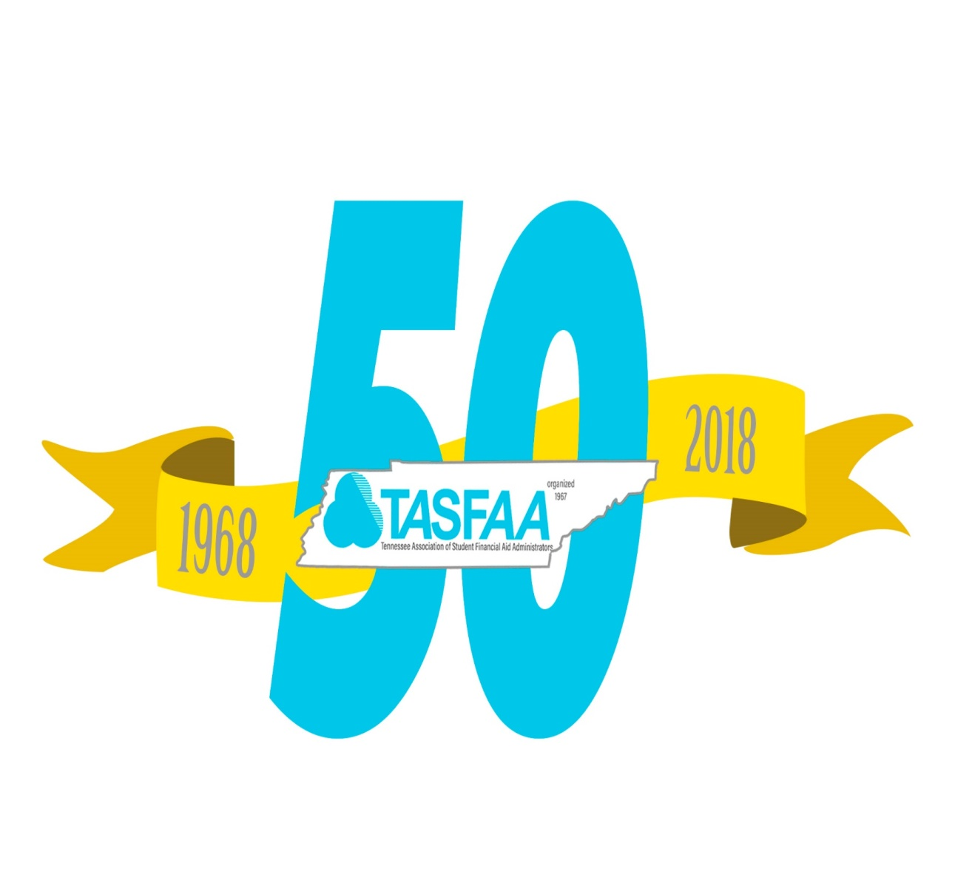
Honoring the Past

Building the Future

2018 Conference Program

April 22 – 25, 2018

Murfreesboro, Tennessee

2017-2018 Executive Board
President Charles Harper, Belmont University
President-Elect Tiffany Summers, Lipscomb University
Past President / Karen Hauser, Vanderbilt University
Nominations /
TSAC Advisory
Secretary Portia Cook, TSAC
Treasurer Stacey McDonald, East Tennessee State University

2017-2018 Sector Representatives

Representative at Large Eric Farmer, TSAC
Private 4 Year April Cross, Lee University
Proprietary Mary Kidd, Nossi College of Art
Public 2 Year Kacee Hardy, Dyersburg State Community College
Public 4 Year Jennifer Buckles, University of Tennessee Chattanooga
TCAT Jo Wallace, TCAT McKenzie

2017-2018 Committee Chairs
Association Governance Jeff Gerkin, University of Tennessee Knoxville Awards Kevin Jacobs, Middle Tennessee State University
Budget/Finance Terri Parchment, TSAC
Conference Leah Louallen, TSAC
Diversity Regina Gilbert, Watkins College of Art & Design
Electronic Services Jeff Norrod, Tennessee Tech University Governmental Relations Ron Gambill, Edsouth
Historical Lacey Weese, Tennessee Wesleyan
Membership Melissa Smith, Vanderbilt University
Public Relations / Blog Holly Malone, Northeast State Community College
Site Selection Sonja McMullen, Sallie Mae
Sponsorship Danette Seale, Carson-Newman University
State Programs Darolyn Porter, TSAC
Training Lester McKenzie, Tennessee Tech University

2018 TASFAA Conference Committee

Leah Louallen, Chair, TSAC

April Cross, Lee University

Ron Gambill, EdSouth

Regina Gilbert, Watkins College of Art & Design

Charles Harper, Belmont University

Karen Hauser, Vanderbilt University

Kevin Jacobs, Middle Tennessee State University

Nadia Keyes, Pellissippi State Community College

Mary Kidd, Nossi College of Art

Holly Malone, Northeast State Community College

Stacey McDonald, East Tennessee State University

Lester McKenzie, Tennessee Tech University

Sonja McMullen, Sallie Mae

Jeff Norrod, Tennessee Tech University

Darolyn Porter, TSAC

Sandra Rockett, TSAC

Danette Seale, Carson-Newman University

Dick Smelser, Pellissippi State Community College

Melissa Smith, Vanderbilt University

Tiffany Summers, Lipscomb University

Celena Tulloss, University of Tennessee Knoxville

Jo Wallace, TCAT McKenzie

Lacey Weese, Tennessee Wesleyan

Stephen White, Middle Tennessee State University

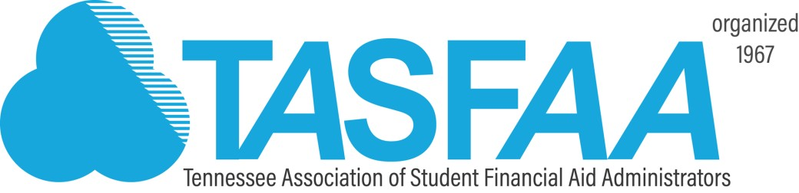

Dear TASFAA Friends,

It is my sincere pleasure to welcome everyone to the 2018 annual TASFAA conference and 50th Anniversary celebration. Our conference theme, Honoring the Past, Building the Future is something that truly represents what we have been able to create in the 50 years as an association. As TASFAA begins its 50th year, we continue to build our legacy of leadership by focusing on the common goal of assisting our students with the means to obtain their academic goals while understanding that education is the key to being able to have higher quality of life than would be possible without a degree. From the first meeting in the Cordell Hull building in Nashville to our current location here at the Embassy Suites in Murfreesboro, we are all here because the members of our association continued to build upon the prior year’s successes with hopes of making each year a little better than the one before while constructing a solid foundation and creating those TASFAA family traditions that make TASFAA what it is today.

Your conference committee has worked diligently to create a four day conference and celebration to remember. Under the leadership of Leah Louallen, the committee has put together an agenda that includes a broad collection of general and concurrent sessions that will provide numerous learning opportunities. Our keynote speaker, Marshall Ramsey, is a two-time Pulitzer Finalist and a nationally syndicated cartoonist who will share his uplifting story while providing moments of humor and reflection. Of course we couldn’t have a 50 year celebration without our favorite Feds, David Bartnicki and Wood Mason, who will join us to relay the most current and relevant regulation updates.

I also want to give tremendous thanks to our sponsors. Without their support we could never do what we are able to do for this association and it is truly appreciated. Please visit the exhibit area often during the conference to learn about key products and services they can provide to your institutions and your students. TASFAA remains fiscally strong as a result of their financial contributions to our conference and the relationships built with each member.

In closing, I want to thank you for entrusting me to serve as your President during 2017-18. This association has given me so much more than I could ever give back. TASFAA has been vital in my professional and personal growth, and I am truly grateful to have been afforded the honor of serving our association as we all continue to build toward the next 50 years.

Sincerely,

Charles Harper
TASFAA President

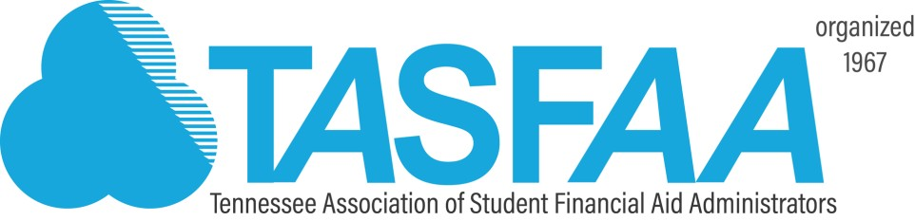

Dear TASFAA Friends,

On behalf of the Conference Committee, it is my great honor to welcome you to the 50th Annual TASFAA Conference and Anniversary Celebration!

This years’ theme, “Honoring the Past and Building the Future”, gives us an opportunity to reflect on the last 50 years of TASFAA, how it has impacted our members, and how it will continue to push us forward into the future. As financial aid administrators, the TASFAA conference allows us to network with our colleagues and friends, to learn, to de-stress and to find ways to turn our challenges into opportunities. I understand each of you is very busy trying to join federal, state, and institutional regulations with excellent customer service. I personally want to thank you for taking time away your office to spend with us at the conference. I hope you will return to your office more knowledgeable and with a better understanding of the profession we love.

I am excited to kick off our conference on Sunday evening with Marshall Ramsey. Marshall is a two-time Pulitzer Finalist whose cartoons have appeared in The New York Times and USA Today. Marshall is uplifting and hilarious! We will also be joined by several distinguished guests throughout the conference including David Bartnicki and Wood Mason, U.S. Department of Education; Sharon Oliver, SASFAA President; David Alexander, KASFAA President; and Michael Birchett, Bluegrass Community & Technical College. I hope you will join me in giving them a big Tennessee welcome!

Please take time to review our program and note the Sponsor Exhibit Hall hours. Stop by often during the conference to thank our sponsors for their support of our training efforts. Their financial support is critical to the mission of TASFAA and our conference. Included in the Exhibit Hall will be a Silent Auction with lots of great items where the funds raised will help local children through Tucker’s House. You can also take a walk down TASFAA’s memory lane and enjoy live entertainment during the breaks.

On Monday afternoon plan to stay after a day of sessions to honor Charles Harper at the President’s Happy Hour. Immediately following, we will celebrate TASFAA’s 50 years of service to students, parents, schools and the great state of Tennessee at the Gala. This will be an incredible event where we honor those that laid the groundwork to get us where we are and celebrate those who are moving us forward to where we will be as an association.

The TASFAA Suite will be open every evening and I hope you will take time to drop by and fellowship with old friends and hopefully make new friends along the way!

I can’t wait for you to experience the training opportunities, networking, fun, and surprises headed your way!

Sincerely,

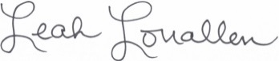

Leah Louallen
Conference Chair

“Carve your name on hearts, not tombstones. A legacy is etched into
the minds of others and the stories they share about you.”
Shannon L. Alder

Welcome to the 2018 TASFAA Annual Conference
Information for Conference Participants

Cell Phones/Electronic Devices
As a courtesy to presenters and attendees, please silence your cell phones and/or electronic devices during the General and Concurrent Sessions.

Conference Attire
Business casual attire is appropriate for the entire conference. Dress for the Anniversary Gala is business professional/cocktail attire.

Hospitality Suite
The TASFAA Hospitality Suite is on the 2nd floor in Suite 228 and welcomes all members. Hours are posted in the program. Join new friends for a pit-stop during the conference.

Meals
If you are a commuter and if you indicated on your registration that you would be eating breakfast then you should have breakfast meal tickets in your registration packet. If you did not indicate that you would be eating breakfast but you now need a meal ticket then you may stop by the registration area.

For conference lunches, individuals who requested vegetarian meals on your registration will have a vegetarian meal ticket in your registration packet. Please present the ticket to the wait staff at the luncheon and they will accommodate your request.

For members staying at the hotel, the Embassy offers a free cocktail hour from 5:30 to 7:30 pm each evening. They offer free drinks and light snacks at this event.

Name Badges
Please wear your name badge at all times as it is necessary for admission to all conference sessions and meals. If you misplace your badge, please go to the registration desk.

Embassy Suites
A floor plan/layout of the hotel is located on the last page of this program.

TASFAA 2018 Conference Sponsorship

Special Thanks
As always, the members of TASFAA express their gratitude for the continued support from generous sponsors. The Grand Patrons, Patrons, Sponsors, and Vendors have allowed us to offer this annual conference for a reasonable fee. Thank you to each and every one of our 2018 conference sponsors. Please visit each of them in the Vendor Area.

Grand Patron Level

minimum $5,500

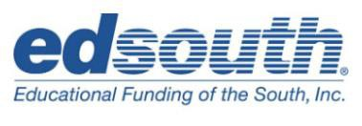

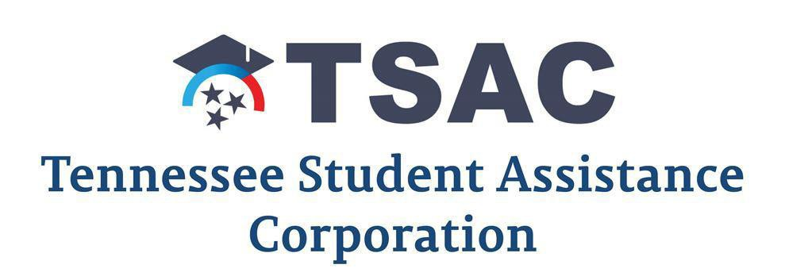

Patron Level
$4,000 - $5,499

Sponsor Level
$3,000 - $3,999

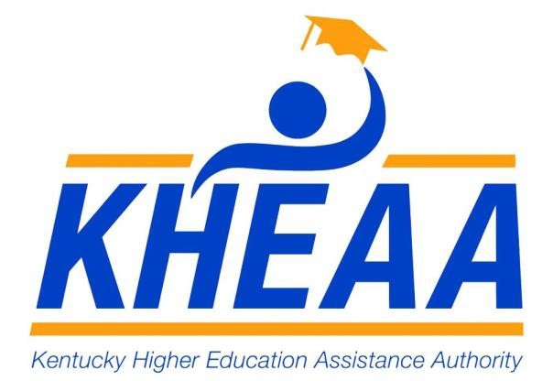
Vendor Level
$2,000-$2,999

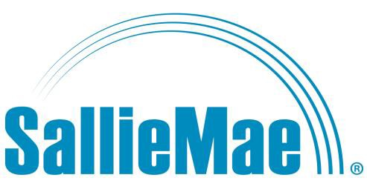
Vendor Level (cont.)
$2,000-$2,999

Pre-Conference Activities on Saturday, April 21, 2018

3:00 – 6:00 pm Conference Preparation / TASFAA Hospitality Suite Open Suite 228

6:00 pm Dinner: Executive Board and Conference Committee

Conference Activities on Sunday, April 22, 2018

6:30 – 8:45 am New Aid Officers Breakfast Hotel Lounge
Executive Board Breakfast

7:45 – 9:00 am Registration: New Aid Officers Workshop Registration Area

9:00 – 10:15 am New Aid Officers Workshop – Session 1 Cambridge AB Executive Board Meeting Broadlands A

10:00 am – 2:00 pm Vendor Area Set-Up Oakleigh AB

10:15 - 10:30 am Break: New Aid Officers Workshop
Executive Board

10:30 am – 12:00 pm New Aid Officers Workshop – Session 2 Cambridge AB
Executive Board Meeting Broadlands A

12:00 – 1:00 pm Luncheon: New Aid Officers, Executive Board, and Broadlands B Conference Committee

1:00 – 2:00 pm Executive Board Meeting Broadlands A

1:00 – 2:30 pm New Aid Officers Workshop – Session 3 Cambridge AB

2:00 – 4:45 pm TASFAA Hospitality Suite Open Suite 228
Vendor Area Open Oakleigh AB
Conference Registration Open Registration Area

2:30 – 3:00 pm Break: New Aid Officers Workshop with Cambridge AB
Executive Board

3:00 – 4:30 pm New Aid Officers Workshop – Session 4 Cambridge AB
Governmental Relations Meeting Broadlands A

3:00 – 4:45 pm NASFAA Credentialing: Mirabella G
Packaging and Notification of Awards

This session introduces participants to awarding and packaging financial aid funds, elements of award notifications, basic packaging models and guidelines for packaging federal financial aid funds. By attending this session, you will be given a code that will allow you to take the test for free to earn this credential. This is a savings of $99.00. Increase your marketability and/or your financial aid understanding.

Presenters: Kevin Jacobs, Middle Tennessee State University
Samantha Sullivan, Vanderbilt University

3:00 – 4:45 pm NASFAA Credentialing: Mirabella H
R2T4

Learn how to handle a student’s Title IV funds when he/she withdraws from school before completing the payment period or period of enrollment. Understand the basic requirements for the return of Title IV funds (R2T4), whether and when to apply the requirements, how to determine the student’s withdrawal date, how to calculate the return of funds for each Title IV program, all applicable deadlines, and the rules for making post-withdrawal disbursements. Once you complete this training you qualify to take the NASFAA Credential test for R2T4 at no cost to you! This is a savings of $99.00.

Presenter: Jennifer Byrd, Nashville State Community College

5:00 – 6:30 pm TASFAA Opening Session Mirabella E

Welcome and Opening Remarks

Charity Introduction: Tucker’s House

Presenter: Marshall Ramsey
Moderator: Charles Harper, TASFAA President
Belmont University

Marshall Ramsey is a two-time Pulitzer Finalist (2002 and 2006). His editorial cartoons are nationally syndicated by Creators Syndicate and have appeared in The New York Times, USA Today and The (Jackson, Miss.) Clarion-Ledger. He is the author of several successful books including three cartoon collections, two short story collections (Fried Chicken and Wine and Chainsaws and Casseroles) and the delightful children’s book Banjo’s Dream. Ramsey’s cartoons, photos, stories and posts are frequently shared on Facebook, Twitter, Pinterest, and Instagram. He’s also the host of the weekly statewide radio program, Now You’re Talking with Marshall Ramsey and the television program Conversations on Mississippi Public Broadcasting.

6:30 – 8:00 pm Dinner Buffet Mirabella F

8:00 – 10:00 pm BINGO! Mirabella IJ

Bring your White Elephant “prize” to get a card to play Bingo with your TASFAA friends. Donate to Tucker’s House and receive additional cards for a greater opportunity to win! Not into Bingo – hang out and visit with your colleagues while enjoying a soft drink, beer, or sangria. We have lots of extra White Elephant prizes so don’t let that stop you from enjoying the fun!
Monday, April 23, 2018

6:30 – 8:45 am Breakfast Hotel Lounge

7:45 – 8:45 am Vendor Area Open Oakleigh AB

7:45 – 11:30 am Conference Registration Registration Area

8:00 – 8:45 am Vendor Session – Next Gen Mirabella A
FWS, Student Employment & Technology –
How to survive budget cuts, be more efficient, and eliminate compliance violations!

Presenter: Taige A. Haines, Next Gen
Celena Tulloss, University of Tennessee Knoxville

9:00 – 10:15 am General Session Mirabella E

COD Update – eCB and R2T4

This session will provide an overview of the move of the eCampus-Based (eCB) to the
Common Origination and Disbursement (COD) System. The discussion will include a
high-level review of current eCB and R2T4 functionality, being integrated into COD with a new look and feel.

Presenter: Wood Mason, U.S. Department of Education
Moderator: Charles Harper, Belmont University

10:15 – 10:45 am Break Oakleigh AB
Special Entertainment: Sam Mullins, TSAC Outreach Specialist
Guitarist/Vocalist

10:15 – 11:45 am Vendor Area Open Oakleigh AB

Concurrent Sessions

10:45-11:45 am Session 1:
Top Compliance Audit and Program Review Findings Mirabella A

Knowing trends in common findings can help your institution avoid compliance issues. The U.S. Department of Education officials regularly announce the top 10 compliance issues discovered when performing audits and program reviews. These findings represent almost half of the compliance issues found in institutions across the country. This presentation will offer a unique perspective to help your institution assess its risk and preparedness in order to avoid these common findings and mitigate their effects.

Presenters: Jeremy Sanders and Katherine Clements, Postlethwaite & Netterville
Moderator: Anna-Marie Smith, University of Memphis

10:45-11:45 am Session 2:
New COD Web Reporting Portal Mirabella B

The Common Origination and Disbursement (COD) System enhanced the reporting
function with a new look to the “Report Portal”. Changes include removing older,
unused reports, changing formats, and expanding others. This session will demonstrate
how the portal can make accessing reports more beneficial for you.

Presenter: Wood Mason, U.S. Department of Education
Moderator: Vicki Cordero, Northeast State Community College

10:45-11:45 am Session 3:
Use of Social Media to Communicate With Students Mirabella C

How can we best use social media to reach our financial aid students? This session will take a comprehensive look at how we can communicate with students more effectively and efficiently.

Presenters: Lester McKenzie, Tennessee Tech University
Joseph Yother, Tennessee Tech University
Jonathan Donald, TSAC
Moderator: Haley Greenway, TCAT Elizabethton

10:45 – 11:45 am Session 4:
How America Pays for College Mirabella D

How America Pays for College, a national study by Sallie Mae and Ipsos of undergraduates and their parents, looks at how families paid for college in the 2016-2017 academic year. This annual study, now in its tenth year, trends attitudes toward the value of college as well as which resources families draw on over time. The study also takes a close look at the relationship between cost and school choice, and at the measures families take to make college more affordable. In addition to the average amounts paid and funding sources used by the typical family, the session will discuss how resources differ by first-in-family students and by region of the country.

Presenter: Sonja McMullen, Sallie Mae
Moderator: April Wolford, University of Tennessee

10:45-11:45 am Session 5:
FERPA HEA Privacy Act – Protecting Student Data Oakleigh C

Sharing student data has suddenly changed. Have you provided award details or FAFSA data to third-party agencies for scholarships, SNAP, rental agencies, DCTAG, PHEAA, GRE waivers, etc.? The White Paper on Financial Aid Data sharing was first published summer 2016 and was a hot topic during the NASFAA Conference. The White Paper was republished with additional restrictions in June 2017. This session will examine the ins and outs of data sharing and provide specific examples to adhere to this new policy. Join this session to learn how to disseminate private data to external agencies, campus partners, and students while complying with federal regulations.

Presenter: Sharon Oliver, SASFAA President, North Carolina Central University
Moderator: Chas Hammond, TSAC

12:00 – 1:15 pm Luncheon Mirabella F

TASFAA Business Meeting
Reserved seating for Executive Board / Conference Committee
NASFAA Update – Marion Dill
TASFAA Service Awards

1:15 – 3:30 pm Conference Registration Registration Area

Concurrent Sessions

1:30 – 2:30 pm Session 1:
Year Round Pell Mirabella A

Come and hear an overview of the new provisions governing year-round Federal
Pell Grants. This session will include new statutory provisions, examples of calculations,
Related COD system updates, and answers to frequently asked questions.

Presenter: David Bartnicki, U.S. Department of Education
Moderator: Samantha Sullivan, Vanderbilt University

1:30 – 2:30 pm Session 2:
Resolving SAR Comment Codes Mirabella B

Recognize the most common Student Aid Report (SAR) comment codes that may be assigned to a student’s SAR or Institutional Student Information Record (ISIR), focusing on codes related to database matches. Understand the possible reason(s) that specific comment codes are assigned to a student’s SAR/ISIR. Determine when a comment code must be resolved and the action the student and/or school must take to correct the situation so that a student is not prevented from receiving additional Title IV aid.

Presenters: April Wolford, University of Tennessee Knoxville
Ashley Edens, Tusculum College
Moderator: Cindy Runnels, TSAC

1:30 – 2:30 pm Session 3:
TN Reconnect Panel Mirabella C

TN Reconnect update and sharing of best practices from Pellissippi State Community
College and Roane State Community College.

Presenters: James Snider, TSAC
Dick Smelser, Pellissippi State Community College
Robin Townson, Roane State Community College
Moderator: Dusty Paulsen, Dyersburg State Community College

1:30 – 2:30 pm Session 4:
SASFAA - Get Involved! Mirabella D

In this session, we will discuss the importance of volunteerism and the opportunities that exist at the state, regional and national levels. We will take a look at the key factors to helping you grow personally and professionally in your career.

Presenter: David Alexander, Florida State President, Kaplan University
Moderator: Felicia Orr, TSAC

2:30 – 3:00 pm Break – snacks provided!! Oakleigh AB
Special Entertainment: Sam Mullins, TSAC Outreach Specialist
Guitarist/Vocalist

2:30 – 4:30 pm Vendor Area Open Oakleigh AB

Concurrent Sessions

3:00-4:00 pm Session 1:
Adds, Drops, & Withdrawals Mirabella A

This session will address the activities a financial aid administrator must perform when
a student adds or drops courses as well as when a student withdraws (excluding R2T4
calculation). Discussion and case scenarios will be provided concerning recalculation
rules and censes dates in various situations as students add and drop courses. This
session will also provide an in-depth explanation concerning student withdrawals on such
topics as school attendance, official and unofficial withdrawals, determining the date of
withdrawal, and reporting deadlines.

Presenter: David Bartnicki, U.S. Department of Education
Moderator: Haley Hendrix, Cleveland State Community College

3:00-4:00 pm Session 2:
Reporting and Adjusting Direct Loan Data / SULA Mirabella B
This session will provide a SULA refresher of the fundamentals and cover loan period
and academic year reporting, and edits. Discussion will be provided on common
mistakes, the SULA calculator, and COD reports.

Presenter: Wood Mason, U.S. Department of Education
Moderator: Amy Wood, Tennessee State University

3:00-4:00 pm Session 3:
Washington Update and Reauthorization Mirabella C

With the challenging political atmosphere in Washington, the upcoming elections in November, and a House Reauthorization Bill that passed the committee, the session will focus on expectations and what you can do to influence the outcome.

Presenter: Ron Gambill, EdSouth
Moderator: Kelly Hawthorne, Vanderbilt University

3:00-4:00 pm Session 4:
TCAT SAP and R2T4 Mirabella D

Come with questions and examples in hand for SAP and R2T4 issues you are having on your campus. We will have a panel of TCAT experts ready with the answers.

Presenter: Cara Suhr, TCAT Nashville
Moderator: Jo Wallace, TCAT McKenzie

3:00-4:00 pm Session 5:
e*GRandS Hands-On Oakleigh C

TSAC staff will help you navigate the e*GRandS system. Learn how to update information, make payments, use the file transfer, refund payments and more! Don’t forget to bring your laptop!

Presenters: Josh Moran, TSAC
Moderator: Robert Biggers, TSAC

4:15 - 5:00 pm Birds of a Feather Sector Sessions

TCAT Schools Mirabella A
Sector Representative: Jo Wallace, TCAT McKenzie

Private 4-Year Schools Mirabella B
Sector Representative: April Cross, Lee University

Community Colleges Mirabella C
Sector Representative: Kacee Hardy, Dyersburg State CC

Public 4-Year Schools Mirabella D
Sector Representative: Jennifer Buckles, University of TN Chattanooga

Proprietary Schools Oakleigh C
Sector Representative: Mary Kidd, Nossi College of Art

5:15 – 6:30 pm President’s Happy Hour Mirabella GH

Come on out to the big league, as we honor and show gratitude to TASFAA’s own heavy hitter, President, Charles Harper, for his year of service and leadership!
Coach Charles stepped up to the plate and hit it out of the park as he led us in Honoring the Past and Building the Future.

6:30 – 10:00 pm 50th Anniversary Gala Mirabella F

Please join us for TASFAA’s 50th Anniversary Celebration and Gala as we travel through time and recognize people and events that helped build the association we know today. The gala will include photo opportunities, music from all the decades, and special entertainment. Dress is business professional to cocktail attire. Don’t miss this once in a lifetime opportunity to ring in TASFAA’s golden years!

10:00 pm TASFAA Hospitality Suite Open Suite 228
All are welcome!

Tuesday, April 24, 2018

6:30 – 8:45 am Breakfast Hotel Lounge

7:45 – 8:45 am Vendor Area Open Oakleigh AB

7:45 – 11:30 am Conference Registration Registration Area

9:00 – 10:00 am General Session - 1 Mirabella E
TSAC Update

TSAC will provide the most current information on the State of Tennessee financial aid programs.

Presenters: Mike Krause, Tim Phelps, Diane LeJeune
Moderator: Charles Harper, Belmont University

9:00 – 10:00 am General Session - 2 Mirabella A
Graduate / Professional School Open Forum

Bring your Graduate / Professional School topics with you to share in an open forum style with your colleagues.

Moderator: Kristie Smith, Vanderbilt University

10:00 – 10:30 am Break Oakleigh AB
Special Entertainment: Bill Riggs, MTSU Financial Aid, saxophone
Bill McCord, MTSU Financial Aid, Bass
Kelli Cox, Trevecca Adjunct Professor, piano

10:00 – 11:45 am Vendor Area Open Oakleigh AB

Concurrent Sessions

10:30 – 11:30 am Session 1:
Modules & Title IV Advanced Topics Mirabella A

This session will assume that attendees are knowledgeable about the basics of
Modules and their impact on Title IV. This session will explore modules at a more
advanced level. This session will focus on academic calendars that utilize standard
terms which contain modules. This session will include a discussion of disbursements
in a module environment, reporting in a module environment and other related topics.

Presenter: David Bartnicki, U.S. Department of Education
Moderator: Ashley Edens, Tusculum College

10:30 – 11:30 am Session 2:
COD Hands-On Advanced Mirabella B

This session will provide an overview of recent modifications to the COD system,
Including year-round Federal Pell Grant changes and Pell Restoration. It will also
include information about system enhancements and modifications for the 2018-2019
award year. Don’t forget your laptop!
Presenter: Wood Mason, U.S. Department of Education
Moderator: Emily Earwood, Union University

10:30 – 11:30 am Session 3:
Homeless Youth / McKinney-Vento Mirabella C

Overview of McKinney-Vento Act to legislation dealing with the education of children
and youth in homeless situations and financial aid for homeless students.

Presenter: Justin C. Singleton, MSSW, LSSW, McKinney-Vento Coordinator
Moderator: Darolyn Porter, TSAC

10:30 – 11:30 am Session 4:
Verification: Please Stop Changing Mirabella D

This session will discuss the 101 of verification, what to look for when completing verification and how to resolve 400/401 codes. It will also give helpful resources that can assist in completing verification.

Presenters: Celia Bradley, Middle Tennessee State University
Kelly Hawthorne, Vanderbilt University
Moderator: Jamie Hamby, Cleveland State Community College

11:45 – 1:00 pm Luncheon Mirabella F
Reserved seating for TASFAA Past Presidents
SASFAA Update – Sharon Oliver
Vendor Appreciation
TASFAA Awards (cont.)

1:30 – 4:30 pm Registration Continues Registration Area

1:30 – 2:30 pm General Session Mirabella E

Different Academic Calendars & Awarding Title IV Aid

This session will explain how different types of academic calendars affect the
administration of Title IV aid. Guidance will be provided on how to determine whether
a program is structured as standard term, no-standard term, or non-term and how each
calendar structure determines what Federal Pell Grant formula is required and how
academic years are defined for Direct Loans.

Presenter: David Bartnicki, U.S. Department of Education
Moderator: Charles Harper, Belmont University

2:30 – 3:00 pm Vendor Area Open Oakleigh AB
Break – snacks provided!!
Special Entertainment: Bill Riggs, MTSU Financial Aid, saxophone
Bill McCord, MTSU Financial Aid, Bass
Kelli Cox, Trevecca Adjunct Professor, piano

Concurrent Sessions

3:00 – 4:00 pm Session 1:
Federal Q & A Mirabella A

This question-and-answer session will give financial aid administrators an opportunity
to ask questions and provide discussion.

Presenters: David Bartnicki, U.S. Department of Education
Wood Mason, U.S. Department of Education
Moderator: Robbie Snapp, Middle Tennessee State University

3:00 – 4:00 pm Session 2:
CPOS: To Pay or Not to Pay TIV Mirabella B

Meeting Title IV compliance of the CPOS (Course Program of Study) regulation is not just a financial aid issue but the responsibility of the entire university. In recent federal program audits institutions have been fined for non-compliance with this requirement. In this panel presentation you will learn how to develop an institution team approach to implementation of processes needed to meet the requirements and how to communicate effectively with your students impacted by the rules.

Presenters: Karen Hauser, Vanderbilt University
Stephen White, Middle Tennessee State University
Robin Townson, Roane State Community College
Moderator: Jana McCall, TSAC

3:00 – 4:00 pm Session 3:
Recognizing Hidden Bias in Professional Judgment Mirabella C

Professional judgment is a privilege of financial aid administrators that assists us in
Providing practical solutions for exceptional situations. This subjective authority
Produces options and opportunities in an otherwise objective regulatory environment.
Our decisions are critical to those affected, but how often do we pause to consider how
our minds come up with our answers? Where did our opinions come from? And are we as certain as we think we are? This session will discuss expanding research on hidden biases from leading psychologists in the field. We will explore the implications of some of their findings together as we examine our own decisions as they relate to professional judgment and the lives of folks we encounter every day.

Presenter: Michael Birchett, Bluegrass Community & Technical College
Moderator: Celena Tulloss, University of Tennessee Knoxville

3:00 – 4:00 pm Session 4: Mirabella D
Going Beyond the Financial Aid Office:
Addressing Student Financial Wellness Comprehensively

Student financial wellness tends to be a silo topic on many campuses, with financial aid
offices bearing the sole responsibility for preparing students for a successful financial future. However, to truly create long term impact and forward progress with students when it comes to understanding personal finance, it should never be the sole responsibility of one individual or one department, nor should content delivered to students be so singular in format or approach. Come learn more about how Pellissippi State Community College addresses financial wellness with their students comprehensively with the collaboration of other campus departments to create
a truly engaging and impactful experience for their students.

Concurrent Sessions

Presenters: Nadia Keyes, Pellissippi State Community College
Annie Flores, Everfi
Allison Fox, Pellissippi State Community College
Moderator: Kimberly Harness, Milligan College

4:15 – 5:15 pm Session 1:
TSAC Listening Session Mirabella A

What updates would you like to see in the e*GRandS data system? TSAC staff will be on hand to listen to your ideas and recommendations.

Presenter: Josh Moran, TSAC
4:15 – 5:15 pm Session 2:
NAOW Wrap-Up Mirabella B

This session is only for the New Aid Officers that attended the workshop on Sunday. We will be recapping the information discussed on Sunday and we will have an open discussion concerning suggestions, what you learned from the rest of the conference, what you enjoyed the most and/or least, volunteering, and networking.

Presenter: Lester McKenzie, Tennessee Tech University

4:15 – 5:15 pm Session 3:
Banner Update for TCATs Mirabella C

The TCAT Banner Team will update us on how Banner implementation will affect our
work and what to expect in the near future.

Presenter: Chelle Travis, TN Board of Regents
Moderator: Jo Wallace, TCAT McKenzie

5:15 pm Dinner on Your Own

8:00 – 10:00 pm TASFAA Hospitality Suite Open Suite 228
All are welcome! Come on in!

Wednesday, April 25, 2018

6:30 – 9:00 am Breakfast Hotel Lounge

7:45 – 9:30 am Conference Registration Registration Area

9:30 – 11:30 am General Session Mirabella E

Federal Update

This session will present information and updates about ED’s Title IV activities and
initiatives.

Presenter: David Bartnicki, U.S. Department of Education
Moderator: Charles Harper, Belmont University

That’s a wrap!

Closing of the 2018 Conference
and 50 Years of TASFAA!!

Embassy Suites Murfreesboro
Conference Center

